

Library Mangment sysem

PROJECT DOCUMENTATION



**APTECH**

**SHAHRAH E FAISAL**

TABLE OF CONTENT

Certificate of completion --------------------------------------------------03  
Acknowledgement -----------------------------------------------------------04  
Problem definition ----------------------------------------------------------05  
Customer requirement specification--------------------------------------06  
Project plan -----------------------------------------------------------------07  
E-r diagrams ----------------------------------------------------------------08

Flow Chart -------------------------------------------------------------------09  
Algorithms -------------------------------------------------------------------10  
Interface design-------------------------------------------------------------13  
Task sheet--------------------------------------------------------------------15  
Unit test check list----------------------------------------------------------15  
Final check list-------------------------------------------------------------15



**Certificate of Completion**

This is to certify that

Mr.Noman Ishaq

Has Successfully Designed and Developed

**I-Project “Library Management System”**

Date of issue **20 Oct 2018**

ACKNOWLEDEGMENT

We are very thankful to Dear Almighty Allah by his grace we are able to complete this task.

We would like to acknowledge all those who helped and guide us all the way to finish this task.

Especially our great teacher **Sir Muhammad Ismail** who guides us and shares his knowledge with us.

Also, we would like to thanks all the staff

We would also like to express our sincere thanks to i-project team from Aptech head office and our project guide at the organization for their valuable guidance and support for completion of this project.

PROBLEM DEFINATION

**The Library System** is a package to be used by Libraries to improve the efficiency of Librarians, Library employees and Users. The Library System to be developed benefits greatly the members and the Librarian of institute. The system provides books catalog and information to members and helps them decide on the books to borrow from the library. The Librarian can keep the books catalog updated all the time so that the members (students and the professors) get the updated information all the time.

Normally the Library have many type of books catalog(Section) for example Physics, Computer IT, Chemistry, History etc. and in each book catalog(Section) there can be multiple books. So making the record of every existing book and those which are borrowed by the members (students and the professors) manually can be more time taking and difficult. So we want a Desktop Application to solve the respective scenarios.



FUNCTIONAL REQUIRMENTS

* The librarian should be provided with the updated information about the books catalog.
* The librarian should be provided with interfaces to add/delete the books available in the book catalog.
* Every member must register himself/herself for example name, father name, and CNIC # and phone no etc. when issuing / borrowing the book 1st time the information of all the members must be stored in a database that is accessible by the Library Management System.
* When issuing a certain book or books to a member, Librarian must have a day’s section in the Book Issuing Frame. I.e. member will tell the librarian that for how long period he/she requires this book.

Note: Any Member cannot borrow/issue a book for more than 15 days.

* The librarian can get the information about the members who have borrowed or returned the books.
* While returning of book, the librarian can check by the application that the book is returned by the member is under the decided time or not. If not, then the member have to pay a Penalty Fee of Rs 50/= on per day late. After this book is again available in its respective catalog.
* The librarian should also be provided with some soft copy reports which are as follows.

1. Updated information about the books, books catalog wise.
2. Issued Books Details.
3. Books which are not returned and the time period is expire.
4. Member wise book issue. (Daily/monthly/yearly).



PROJECT PLAN

Project Approach

Step I: Understanding and Analysis the Requirement specification

Step II: Gathering the Required Information

Step III: E-R diagrams / prototyping

Step IV: Code implementation

Step V: Testing

Step VI: Documentation

Step VII: Review  
  
Step VIII: Project Submission

Goals and Objectives

The business goals and objectives for this project will focus on implementing Desktop Application that

1. To build a system that can receive input and generate automatically output in easy way and short time.
2. To build a monitoring system that is able to monitor and manage all library operations efficiently.
3. Give an opportunity to librarians to reduce mistakes that always happen during manual method.
4. To store properly library items in order to maintain their security.
5. Search record module.
6. Book Borrowing System Module.
7. Report Generator

E-R DIGRAMS

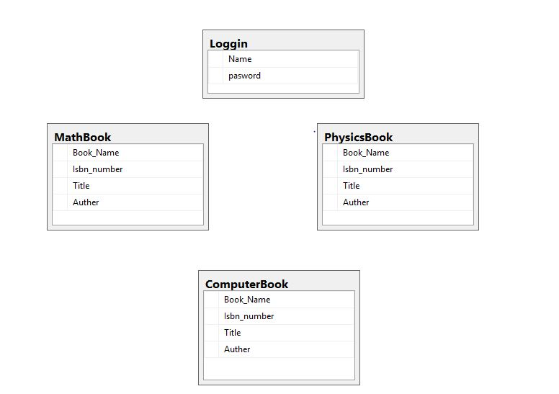

FLOWCHART

LOGIN

Issue Books

Books Information

Members

Catalog

Issue Books

Return Book

Search Books

Books

Reports

Dashboard

Member Wise Book Issue

ALGORITHMS

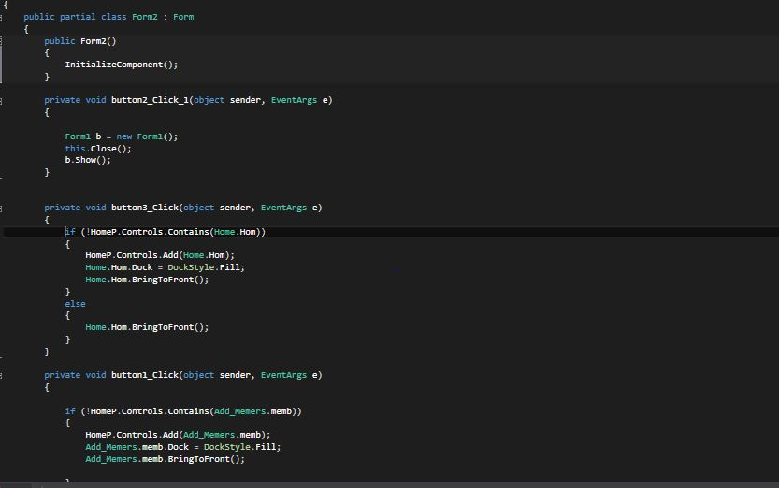

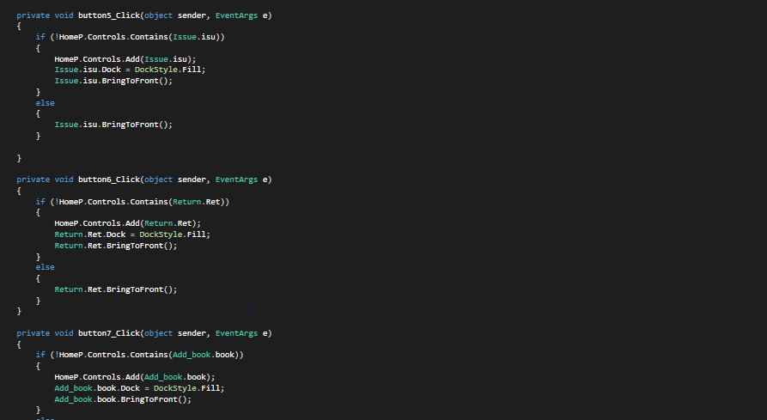

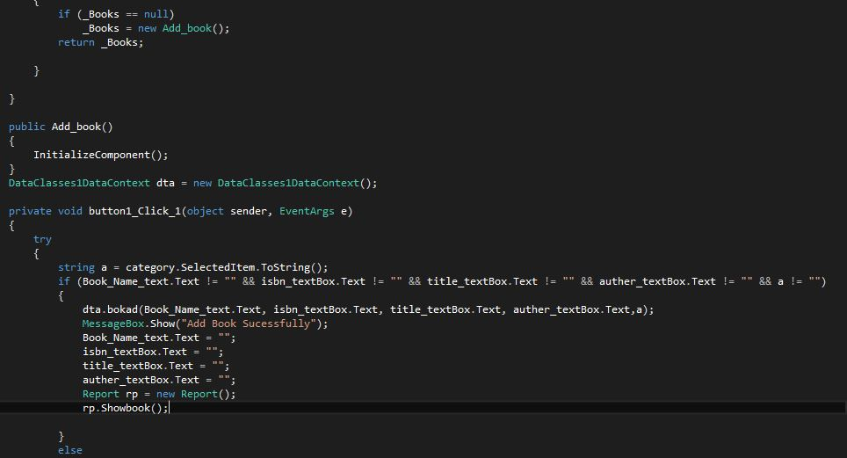

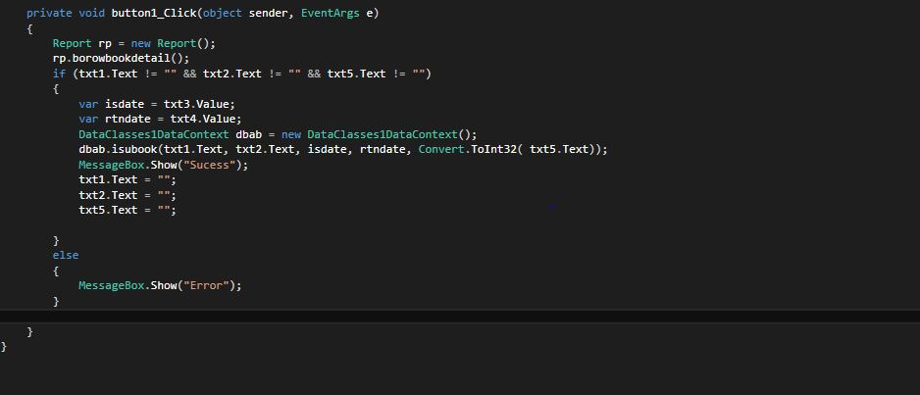

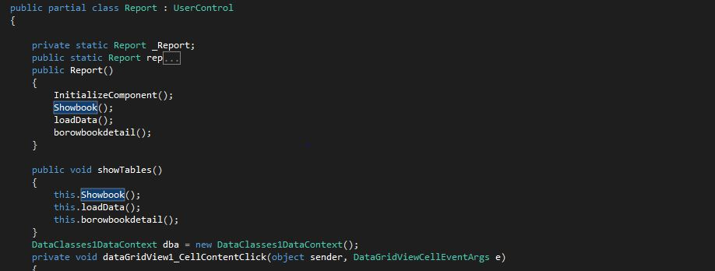

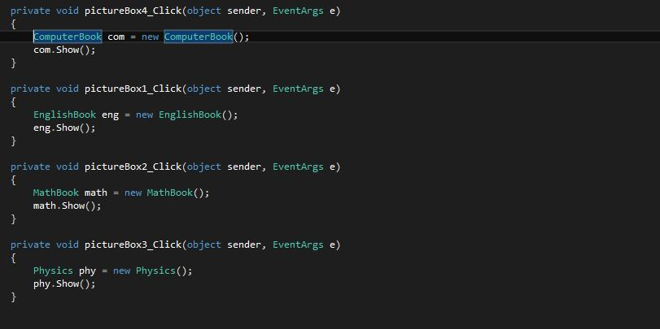

INTERFACE DESIGN  
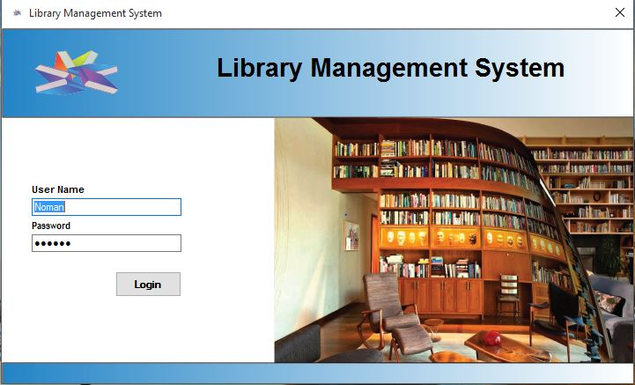

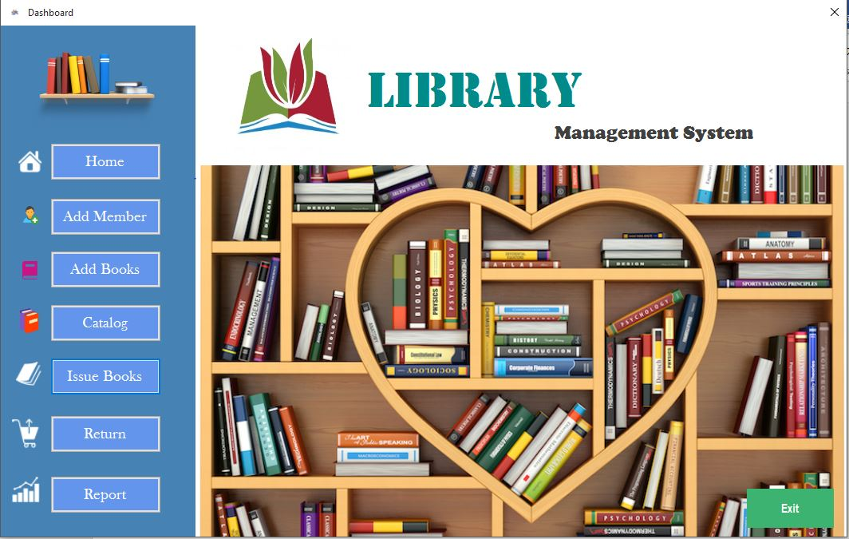

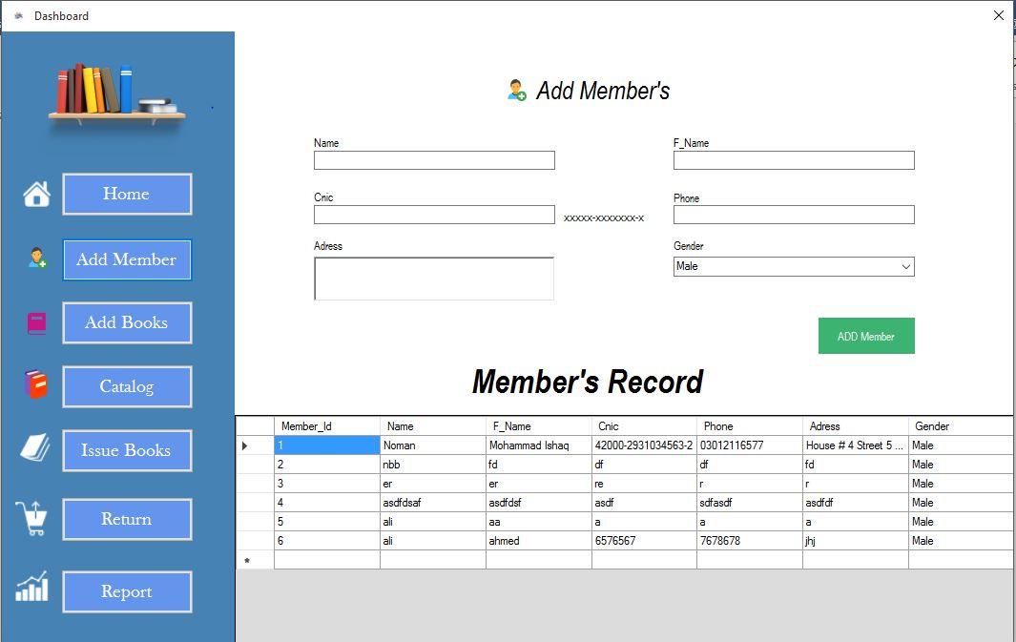

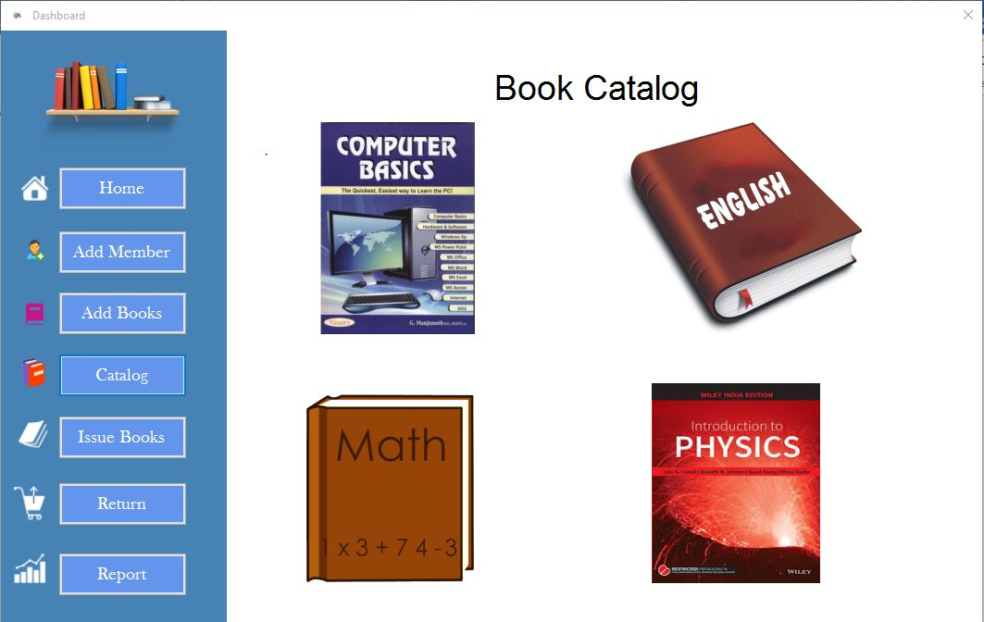

TASK SHEET

|  |  |  |
| --- | --- | --- |
| Date | Task | Resource |
|  |  |  |
|  |  |  |
|  |  |  |

UNIT TEST CHECK LIST

|  |  |
| --- | --- |
|  |  |
|  |  |
|  |  |
|  |  |
|  |  |

FINAL CHECK LIST

All the requirements specified by customer has been checked